Hospital Data Visualization

Home Screen 2

Map Plot Features 4

a. Plot with Map 4

b. Map Plot with Data in Mouse Over 5

c. Map plot with Cluster 6

County Wise Plot 7

a. Show County in Select Box 7

b. Select County from Box 8

c. Showing the Selected Count Data 9

Compare Sector Data 10

a. Comparison Chart 11

Hospital Data Visualization

# Home Screen

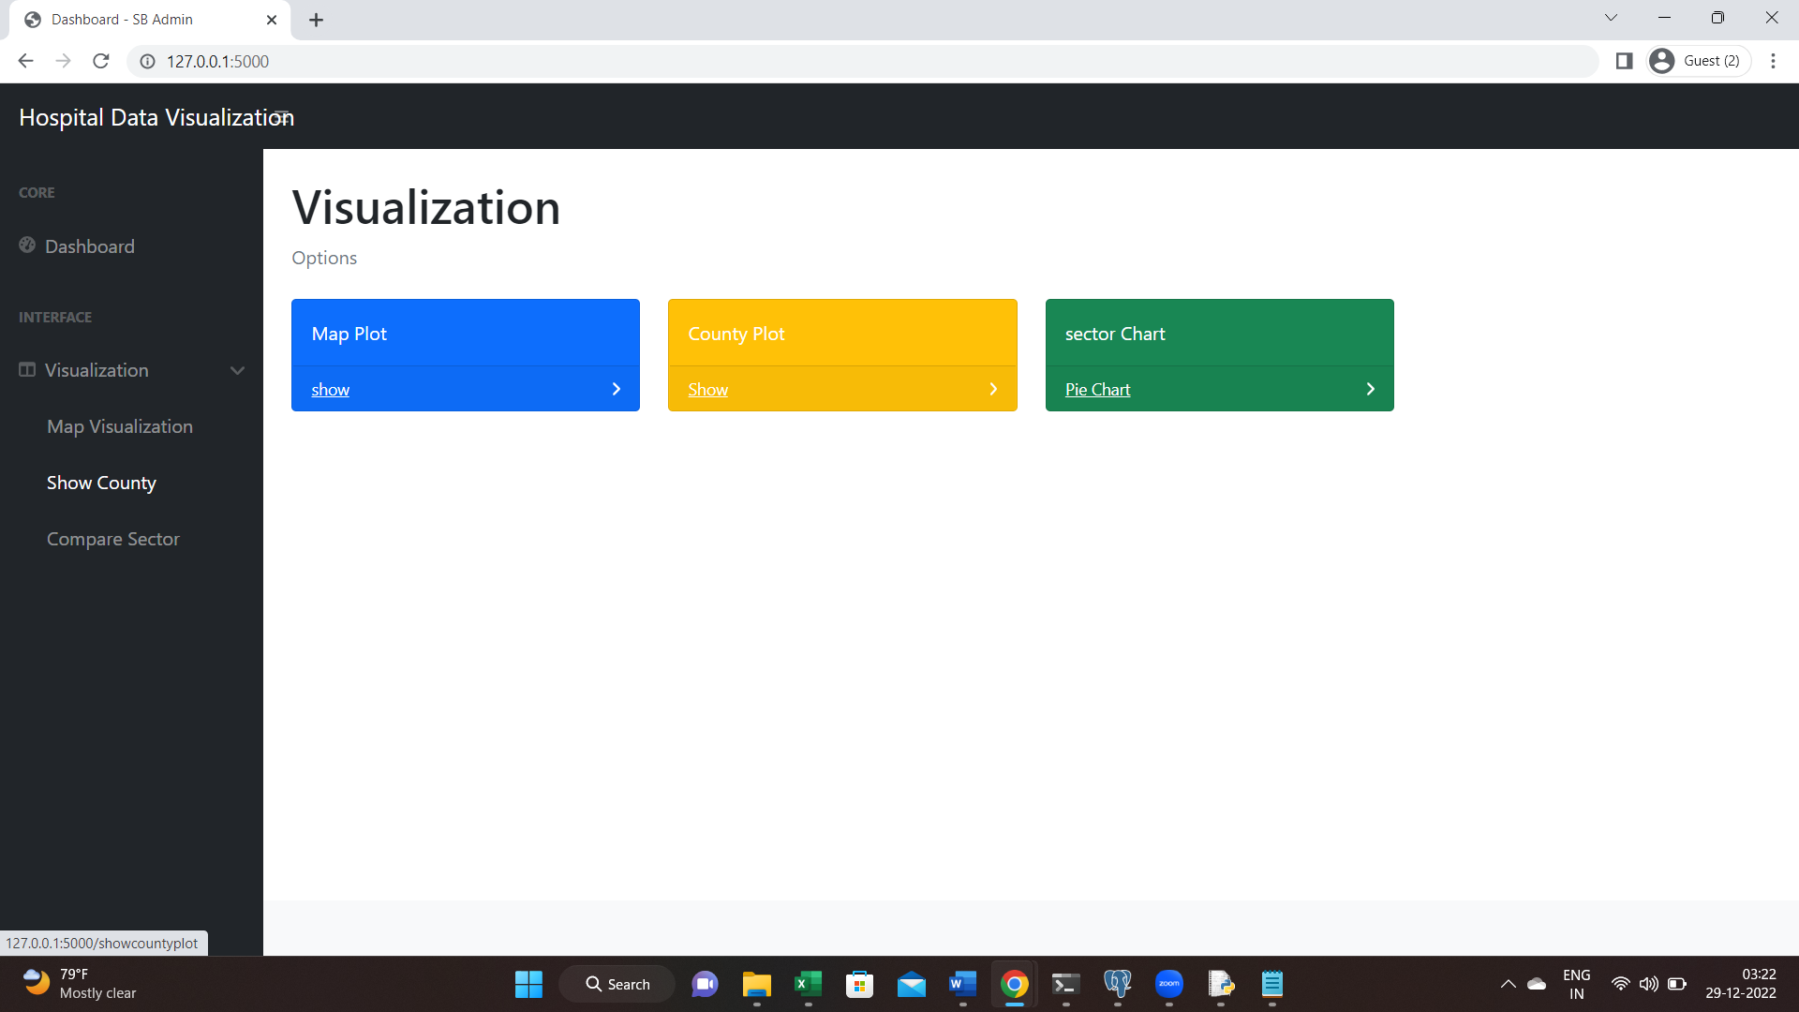

# Map Plot Features

## Plot with Map

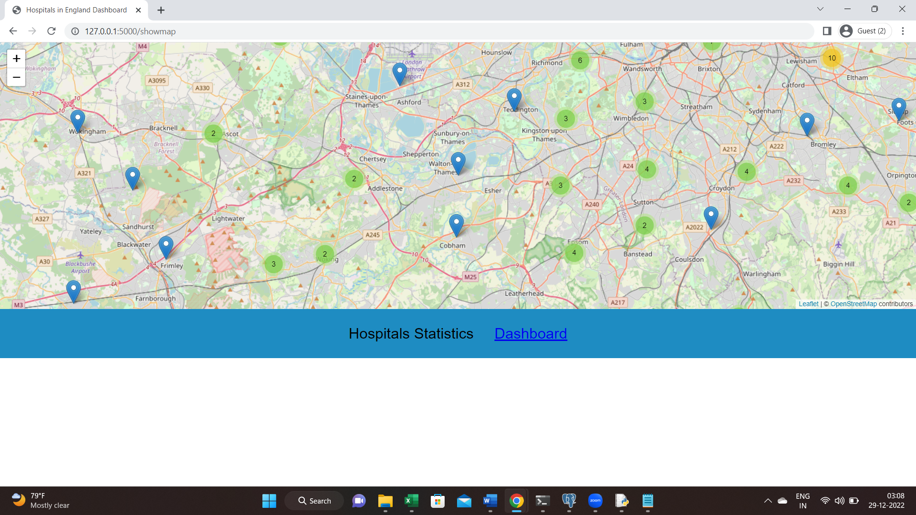

## Map Plot with Data in Mouse Over

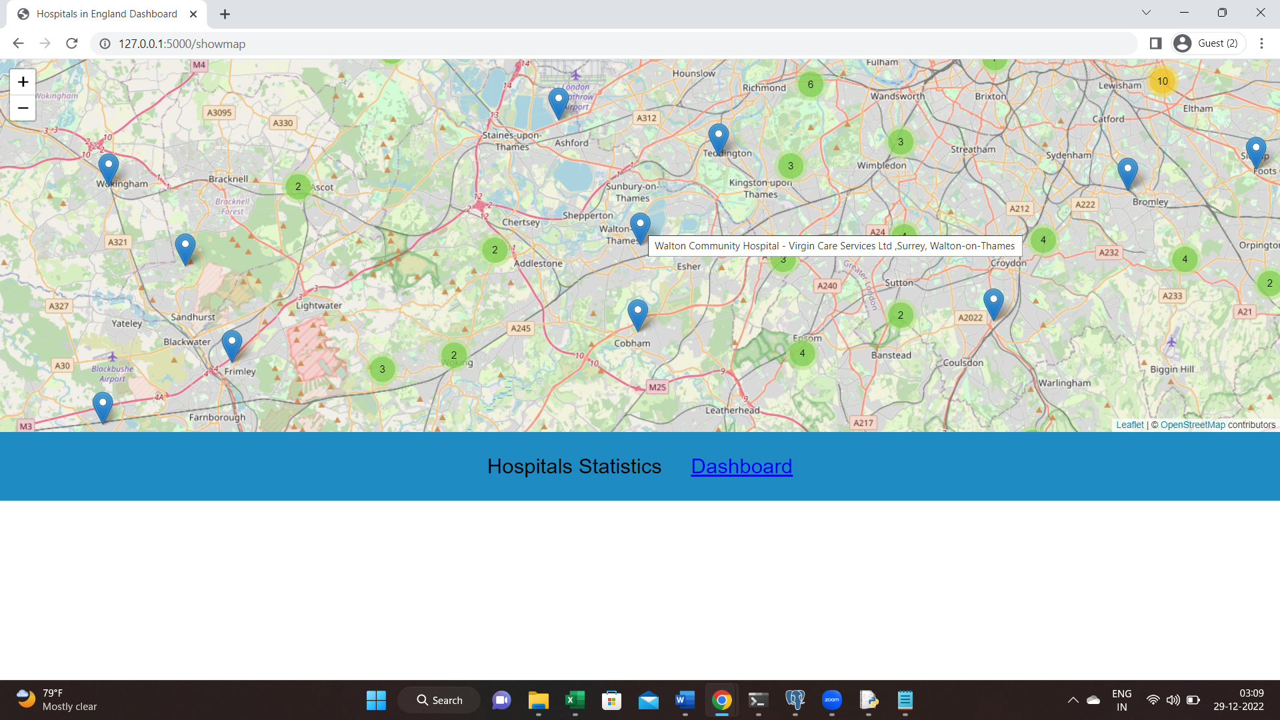

## Map plot with Cluster

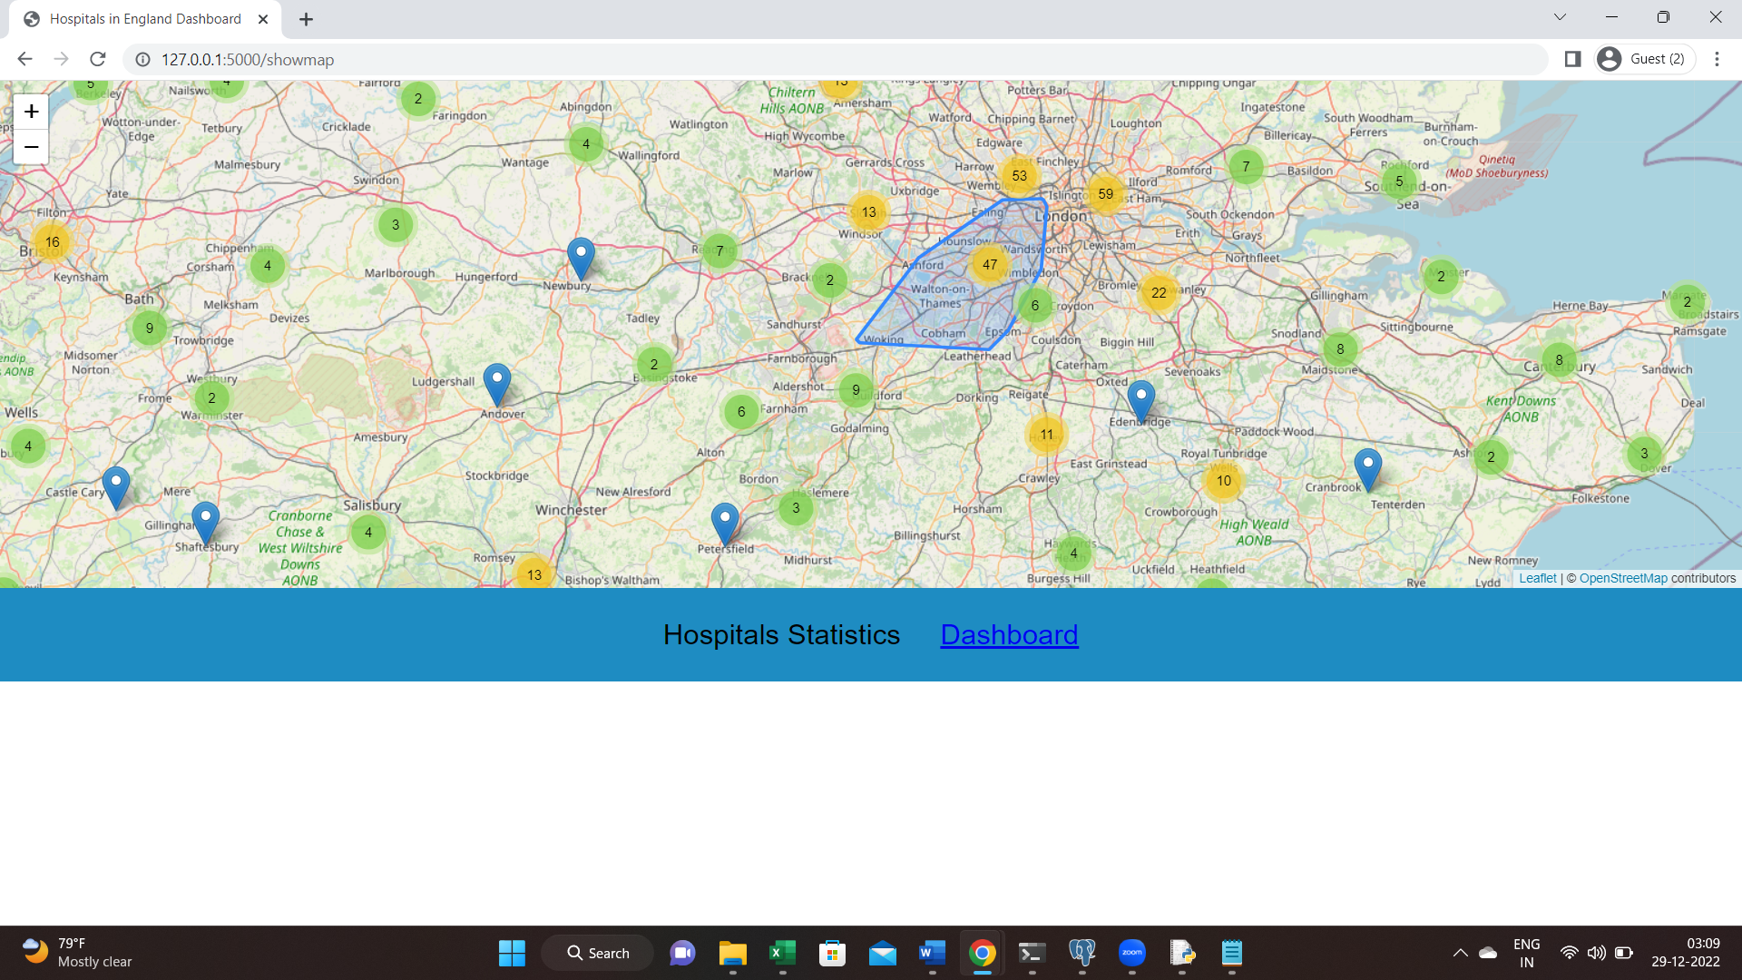

# County Wise Plot

## Show County in Select Box

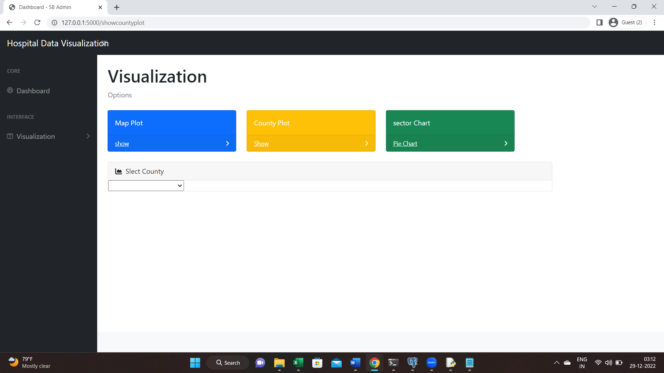

## Select County from Box

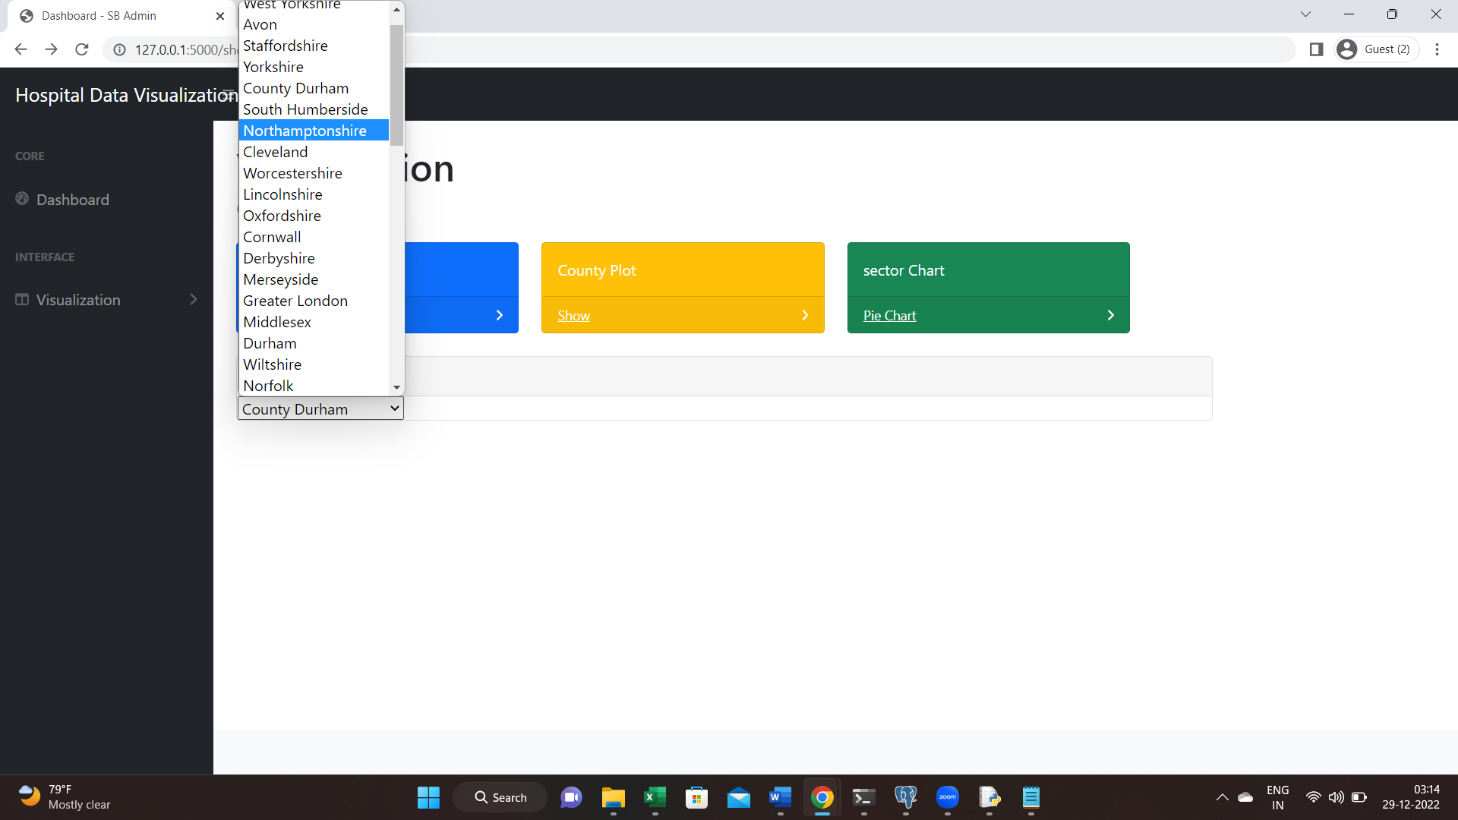

## Showing the Selected Count Data

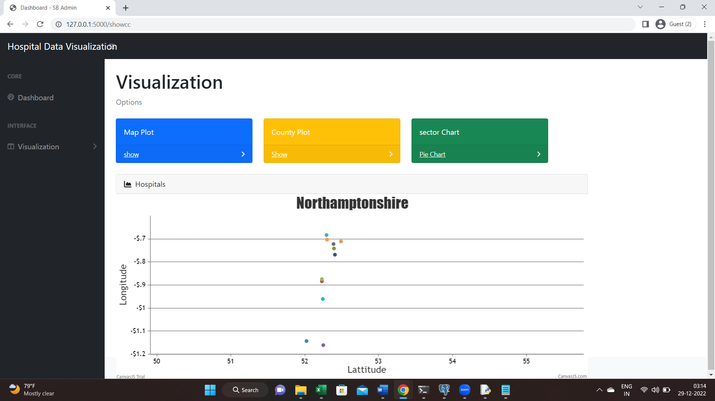

# Compare Sector Data

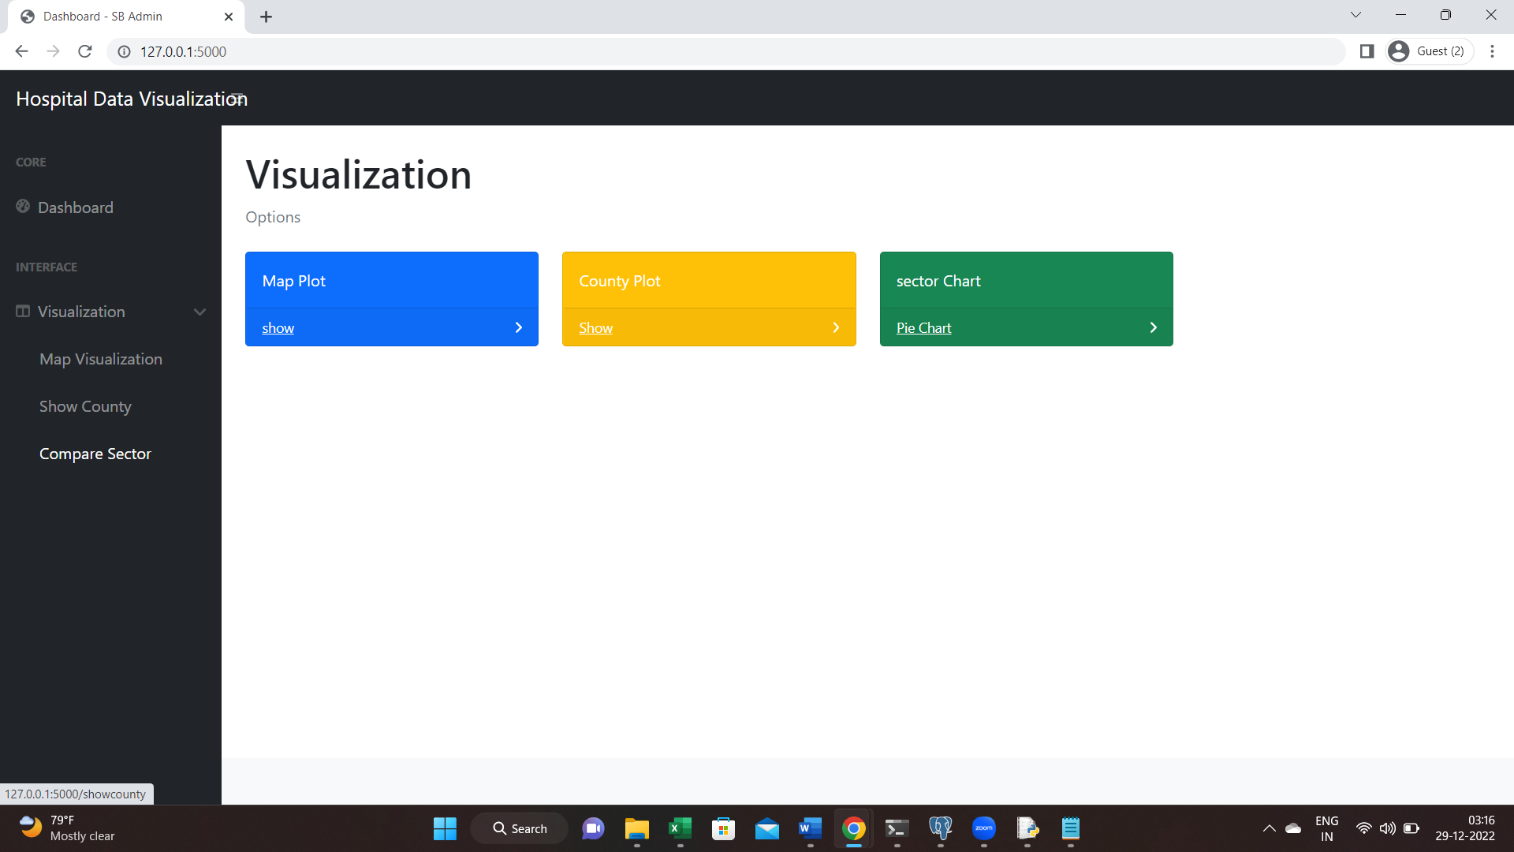

## Comparison Chart

